

**WEB TECHNOLOGIES**

**LAB TERMINAL**

**NAME:**

**MUHAMMAD MUAAZ SHOAIB**

**REG. NO:**

**FA20-BCS-074**

**CLASS:**

**BCS-6B**

**SUBMITTED TO:**

**MR. TABISH**

**DATE:**

**15-JUNE-2023**

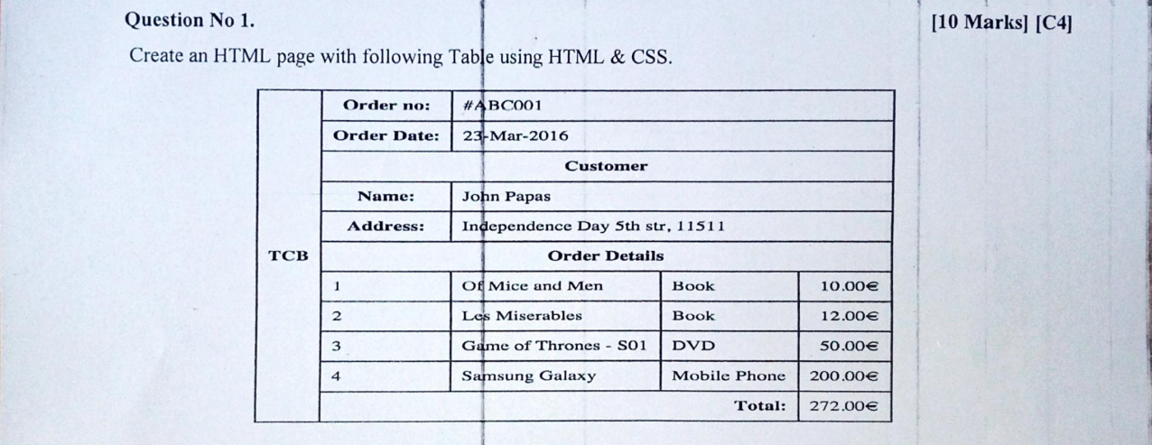

<!DOCTYPE html>

<html lang="en">

<head>

    <meta charset="UTF-8">

    <meta name="viewport" content="width=device-width, initial-scale=1.0">

    <title>Question 01</title>

    <style>

        tr {

            text-align: center;

        }

        td {

            border: 1px solid;

        }

    </style>

</head>

<body>

    <table style="border: 1px solid; width: 60%;">

        <tr>

            <td rowspan="11" style="font-weight: bold;">TCB</td>

            <td style="font-weight: bold;">Order No:</td>

            <td colspan="3">#ABC001</td>

        </tr>

        <tr>

            <td style="font-weight: bold;">Order Date:</td>

            <td colspan="3">23-May-2016</td>

        </tr>

        <tr>

            <td style="font-weight: bold;" colspan="4">Customer</td>

        </tr>

        <tr>

            <td style="font-weight: bold;">Name:</td>

            <td colspan="3">John papes</td>

        </tr>

        <tr>

            <td style="font-weight: bold;">Address:</td>

            <td colspan="3">Independence Day 5th str, 1151</td>

        </tr>

        <tr>

            <td style="font-weight: bold;" colspan="4">Order Details</td>

        </tr>

        <tr>

            <td>1</td>

            <td>Of mice and men</td>

            <td>Book</td>

            <td>10.00 euro</td>

        </tr>

        <tr>

            <td>2</td>

            <td>Les Miserables</td>

            <td>Book</td>

            <td>12.00 euro</td>

        </tr>

        <tr>

            <td>3</td>

            <td>Games of Throne- S01</td>

            <td>DVD</td>

            <td>50.00 euro</td>

        </tr>

        <tr>

            <td>4</td>

            <td>Samsung Galaxy</td>

            <td>Phone</td>

            <td>200.00 euro</td>

        </tr>

        <tr>

            <td style="text-align: right; font-weight: bold;" colspan="3">Total:</td>

            <td style="float: clear;">272.00$</td>

        </tr>

    </table>

</body>

</html>

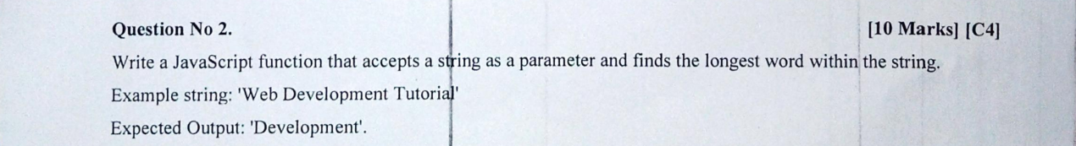

<!DOCTYPE html>

<html>

<head>

  <title>Longest Word Finder</title>

  <script>

    function findLongestWord(str) {

      var words = str.split(" ");

      var longestWord = "";

      var longestLength = 0;

      for (var i = 0; i < words.length; i++) {

        var word = words[i];

        if (word.length > longestLength) {

          longestWord = word;

          longestLength = word.length;

        }

      }

      return longestWord;

    }

    function findLongestWordInInput() {

      var input = document.getElementById("inputString").value;

      var longestWord = findLongestWord(input);

      document.getElementById("result").innerHTML = "Longest word: " + longestWord;

    }

  </script>

</head>

<body>

  <h1>Longest Word Finder</h1>

  <input type="text" id="inputString" placeholder="Enter a string">

  <button onclick="findLongestWordInInput()">Find Longest Word</button>

  <p id="result"></p>

</body>

</html>

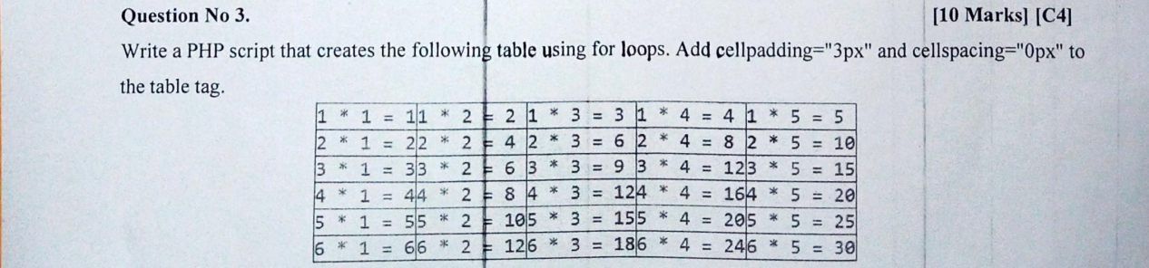<?php

echo '<table cellpadding="3px" cellspacing="0px">';

for ($i = 1; $i <= 6; $i++) {

    echo '<tr>';

    for ($j = 1; $j <= 5; $j++) {

    $product = $i * $j;

        echo '<td style="width: 100px; height: 30px; border: 1px solid black; text-align: center;">' . $i . ' * ' . $j . ' = ' . $product .  '</td>';

    }

    echo '</tr>';

}

echo '</table>';

?>



